|  |  |  |
| --- | --- | --- |
|  |  | |
| Pearson  Higher Nationals in | | |
| Computing | | |
| ASSESSMENT BRIEF | | |
| Unit: | 10 Website Design & Development | |
| For use with the Higher National Certificate and  Higher National Diploma in Computing | | |
| Brief Number: | | 1 |
| First teaching from September 2017 | | |
| **Issue** | **1** | |



Assessment Brief

|  |  |
| --- | --- |
| Student Name/ID Number | … |
| **Unit Number and Title** | **10: Website Design & Development** |
| Academic Year | 2018 - 2019 |
| Unit Tutor | Nguyen Minh Long |
| **Assignment Title** | **Web Services Presentation and Guidebook** |
| **Issue Date** | **January 08 2019** |
| Submission Date | March 07 2019 |
| IV Name & Date |  |

|  |
| --- |
| **Submission Format** |
| The submission is in the form of two documents/files:   1. A report document including some sections  * Section 1: A review of appreciate web design principles, standards and guidelines. * Section 2: Design document for company's website. * Section 3: Implementation of website design. * Section 4: Test plan and test evaluation.  1. A compressed file that encapsulates all source code and particular necessary resources including files of images, style sheets, java script and other files to support to install multipage website such as sql script and installation guide.   You are required to make use of headings, paragraphs, subsections and illustrations as appropriate, and all work must be supported with research and referenced using the Harvard referencing system. |

|  |
| --- |
| **Unit Learning Outcomes** |
| **LO3** Utilise website technologies, tools and techniques with good design principles to create a multipage website.  **LO4** Create and use a Test Plan to review the performance and design of a multipage website. |
| **Assignment Brief and Guidance** |
| You work as a full-stack web team leader for a leading Web Development and Consulting company. Your team is about to build a website for the company.  In order to finish your work effectively you need to review all appropriate principles, standards and guidelines for website designing and development, evaluate all technical challenges to produce a good design document for your company website with wireframes, functional illustrations and a full set of client and user requirements. Then, you lead your team to utilize web design and development technologies, tools and techniques to implement your web design to develop your company website. To get good result, you always ask your team for following your design document by comparison between created multipage website with your design document and evaluation.  As your role, to ensure that the multipage website for company's website developed by your team is a high quality product, you also need to ask your team members to follow quality assurance process and implement it during your design and development stages by creating a suitable test plan. The test phase should be seriously implemented by reviewing and analysing all test results to evaluate applied quality assurance process and point out suggestions of improvements for company's website |

|  |  |  |
| --- | --- | --- |
| Learning Outcomes and Assessment Criteria | | |
| Pass | Merit | Distinction |
| **LO3** Utilise website technologies, tools and techniques with good design principles to create a multipage website | | **D2** Critically evaluate the design and development process against your design document and analyse any technical challenges. |
| **P5** Create a design document for a branded, multipage website supported with medium fidelity wireframes and a full set of client and user requirements.  **P6** Use your design document with appropriate principles, standards and guidelines to produce a branded, multipage website supported with realistic content. | **M4** Compare and contrast the multipage website created to the design document. |
| **LO4** Create and use a Test Plan to review the performance and design of a multipage website | | **D3** Critically evaluate the results of your Test Plan and include a review of the overall success of your multipage website; use this evaluation to explain any areas of success and provide justified  recommendations for areas that require improvement. |
| **P7** Create a suitable Test Plan identifying key performance areas and use it to review the functionality and performance of your website. User Experience (UX) and User Interface (UI). | **M5** Evaluate the Quality Assurance (QA) process and review how it was implemented during your design and development stages. |

**P5 .** Create a design document for a branded, multipage website supported with medium fidelity wireframes and a full set of client and user requirements.

Before you begin creating webpages for a website, you must have a solid web design

plan. Designing a website includes planning, articulating the website’s purpose,

identifying the target audience, creating a site map and wireframe, selecting graphics

and colors to use in the site, and determining whether to design for an optimal viewing

experience across a range of devices.

|  |  |
| --- | --- |
| Purpose of  the Website | To promote services and get new customers. The mission of Web Marketing: use the website to advertise products, where to sell products, give product pricing information. |
| Target  Audience | Web Marketing customers are company ,  single customers, large and small units |
| Multiplatform  display | Web Marketing recognizes the growth in smartphone and tablet usage and wants a  single website that provides an optimal viewing experience regardless of whether visitors  are using a desktop, laptop, tablet, or smartphone. |
| Wireframe  and Site Map | The initial website will consist of ve webpages arranged in a hierarchal structure with links  to the home page on every page. Each webpage will include a header area, navigation  area, main content area, and footer area. |
| Graphics | Web Marketing want design logo to help with local  branding. Photos of the facility, members, and staff will increase visual appeal. |
| Color | Web Marketing uses its color to develop design and bright future |
| Typography | To make the content easy to read, the website will use a serif font style for paragraphs,  lists, and other body content, while providing contrast by using a sans serif font style for  headings. |
| Accessibility | Standard accessibility attributes, such as alternative text for graphics, will be used to  address accessibility. See Appendix D for an accessibility reference list. |

Site Map

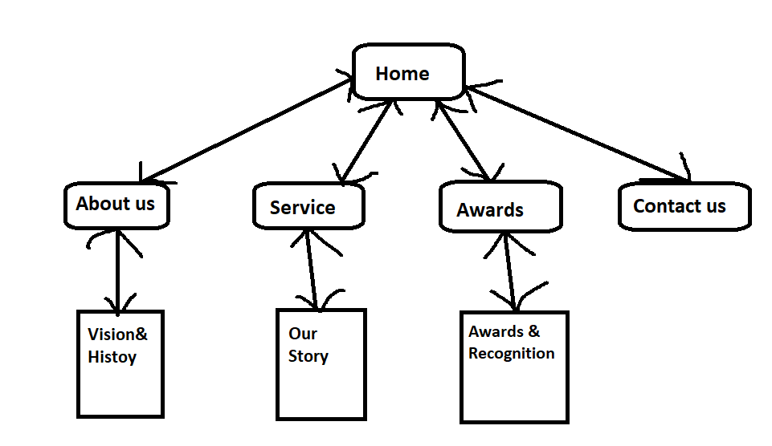

The webpages will include the following content:

. Home

. About us

. Service

. Awards

. Contact us

**Wireframs**

Home Page : Desktop size & Moblie Size

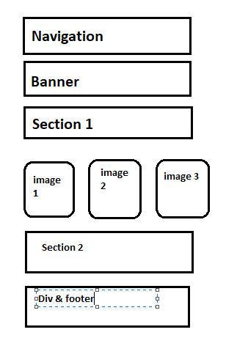

About us : Desktop size

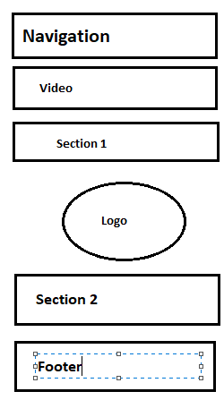

About us : Moblie Size

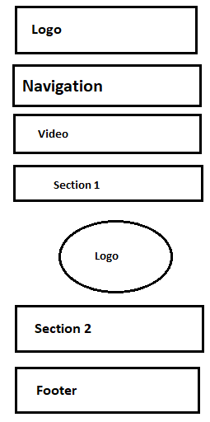

Service : Desktop size

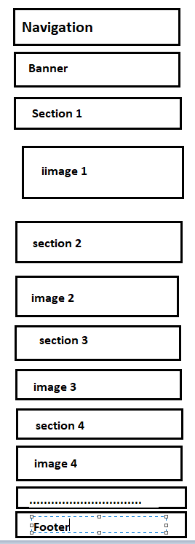

Service : Moblie Size

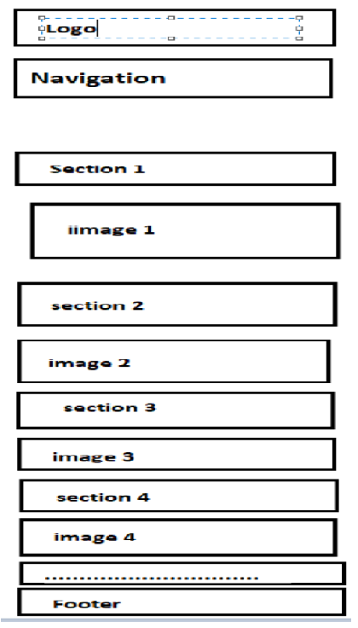

Awards : Desktop Size

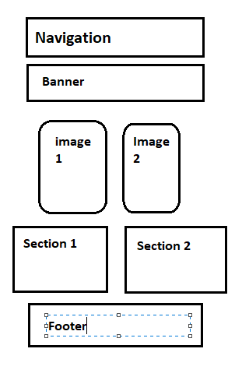

Awards : Moblie size

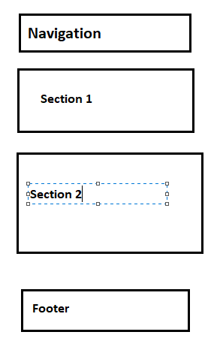

Contact us : Desktop size

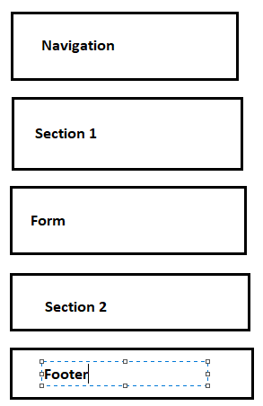

Contact us : Moblie Size

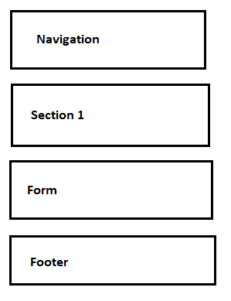

**P6** Use your design document with appropriate principles, standards and guidelines to produce a branded, multipage website supported with realistic content.

This is my web site about company web Marketing.. I have done it based on my wireframes design.

This is the page of Home With desktop design



This is the page of Home with Moblie Design



This is the page of About with desktop design



This is the page of About with Moblie design



This is the page of Service with desktop design



This is the page of service with Moblie design



This is the page of Contact with desktop design

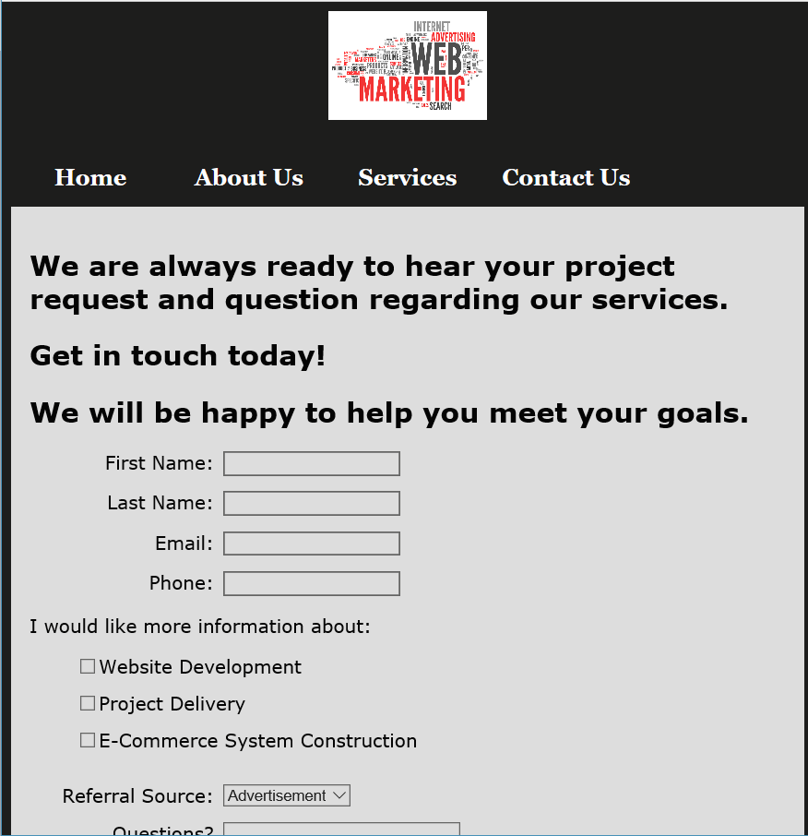

This is the page of Contact with Moblie design

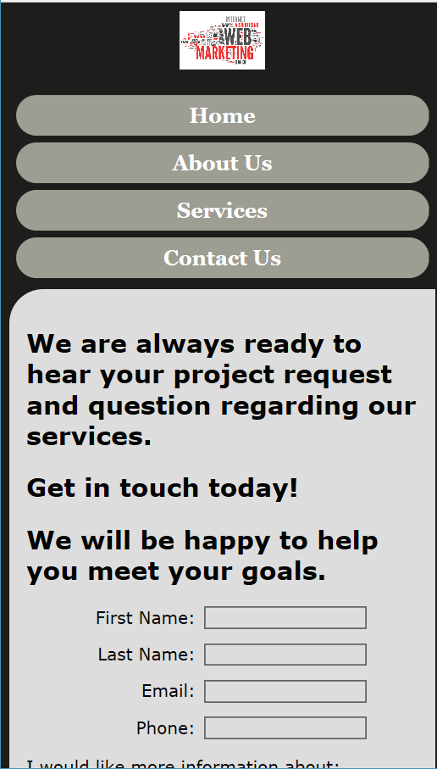

**P7** Create a suitable Test Plan identifying key performance areas and use it to review the functionality and performance of your website. User Experience (UX) and User Interface (UI).

Test

|  |  |  |  |  |
| --- | --- | --- | --- | --- |
| Test | What is being test ? | How | Test data used | Expected Result |
| 1 | Order of input on data entry screen | Enter data from data capture sheet into the form on the data entry screen | Set 1 | Data entry order is the same as that on the data capture sheet |
| 2 | Validation of input | Enter typical values, boundary value, values that should be rejected | Set 2 | Good data accepted, bad data rejected |
| 3 | Accurate calculations | Use the tool to measure something for which you know the exact value. | Set 3 | Data set 3A |
| 4 | Scaled output | Creating A Summary Report For Drive Time / Distance Polygons The below example uses an address location as a starting point. | Set 4 | paginated output |
| 5 | Retest validation of input | Forms frequently include required input that needs to be clearly identified using labels | Set 5 | None |

*Test log*

|  |  |  |  |  |  |  |  |
| --- | --- | --- | --- | --- | --- | --- | --- |
| Test | What is being tested | How | Test data used | Expected results | Date | Actual results | Action taken |
| 1 | Functionality Testing | Check internal links. | <a href="element.html">Home</a> | Jump to page element | 1/7 | Done |  |
| 2 | Usability testing | Check ease of learning | Try using the brower | The website should be easy to use | 2/7 | Done |  |
| 3 | Interface testing | Testing the server | Web server and application server interface | Running server without error | 3/7 | error | Re-code |
| 4 | Compatibility testing | Check compatibility browser | Use some different browser with different versions | Nothing interupted | 2/7 | Error | Re-code |
| 5 | Performance testing | Web load testing | Test page with many user | Browser surfs smoothly | 3/7 | Done |  |